Name: Nitesh Kumar
Roll no: 25K-0631

DLD Lab 01 Tasks

Task 01
Circuit Design:
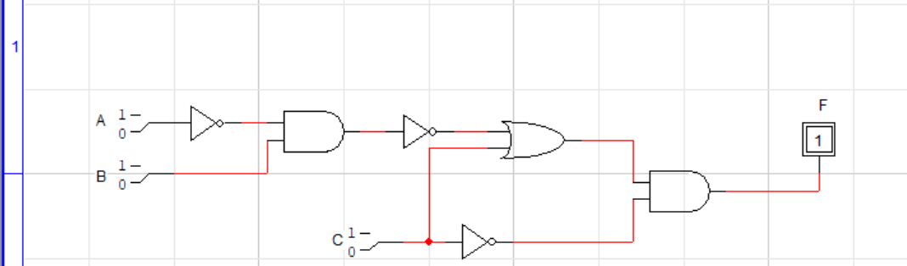

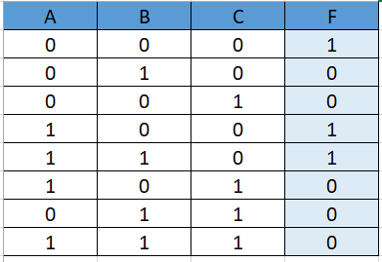
Truth Table:

Task 02
- A+B+C+D
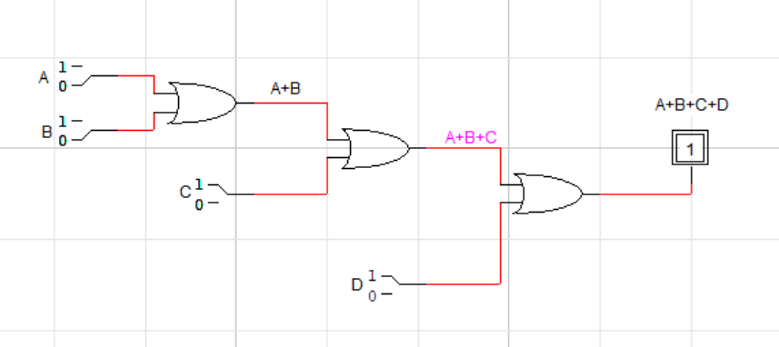

- ABCD
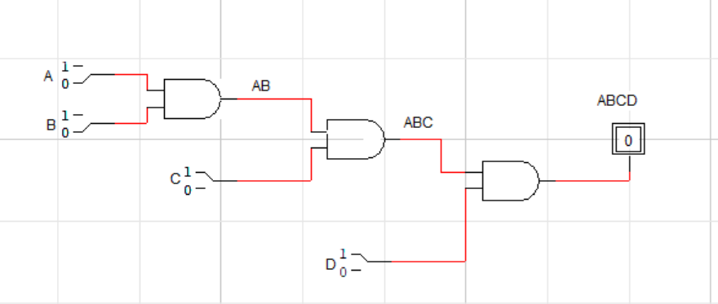

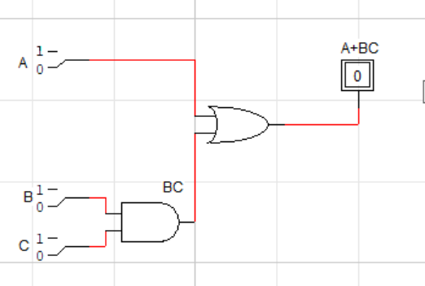
3. A+ BC

4. ABC+D
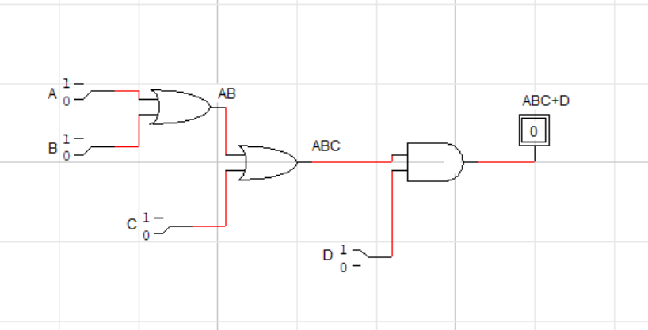

Task 03
Logic circuit:
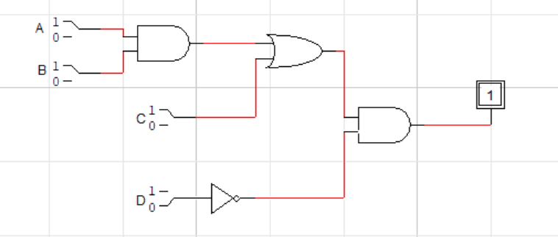

Truth Table:
